


Journal for …………………………………………………………………

“It does not matter how slowly you go as long as you do not stop.”
– Confucius

“Recovery is a deeply personal, unique process of changing one’s attitudes, values, feelings, goals, skills and/or roles. It is a way of living a satisfying, hopeful, and contributing life even with limitations caused by the illness. Recovery involved the development of new meaning and purpose in one’s life as one grows beyond the catastrophic effects of mental illness.”
W A Anthony 1993

About Your Journal

This journal has been written as a tool to support your well-being alongside the courses offered at Recovery College Cornwall. The journal is yours and will not be seen by anyone unless you choose to share it.

Your journal is divided into six sections and you will notice links to websites where you can find more information on areas you may want to explore further.

Consider the best way to complete your journal - what kind of environment (quiet or busy), what time of day do you work best, on your own or with input from family/friends? Remember, complete it at your own pace.



Section One: Recognise Where You Are

What are my strengths?

What are my areas to develop?

What are the current obstacles to my recovery?

What am I hoping to get from my journey with Recovery College?

Check in

Warwick-Edinburgh Scale

The Warwick-Edinburgh Scale is one way to measure your wellbeing. Circle the statements below to reflect how you are feeling at this time.

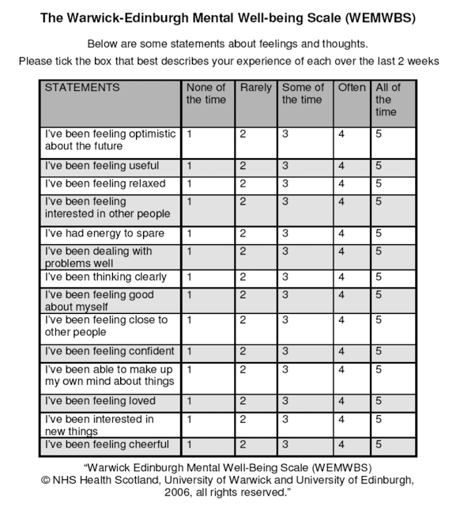

Ideas About Recovery

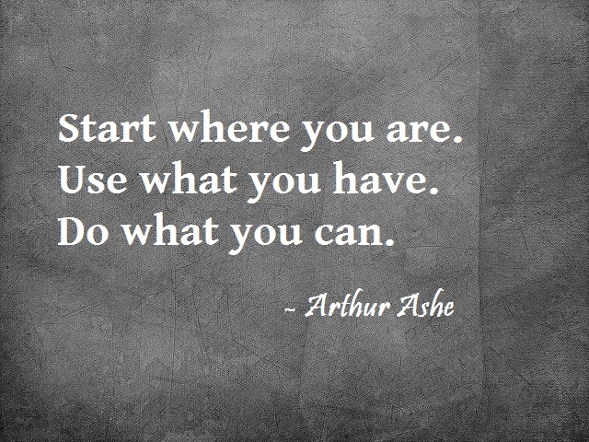


These quotes offer you some ideas on how mental health and recovery can be defined.

What does mental health mean to you?

Summary

In this section we looked at:

- Your starting point
- What you’re hoping to get from your recovery
- What mental health recovery means to you

Additional Activity

- Research some positive/inspirational quotes related to recovery or write down three positive affirmations

Section Two: Holding Hope

‘A holder of hope is someone who believes in you and your capacity to recover’ (Glover, 2010).

Who is a holder of hope for you?

Stress Bucket Model
Everyone experiences stress differently.
Visualise a ‘Stress Container’ (see picture below). Our vulnerability to stress varies and this will impact on the size of our Stress Container which is down to a combination of factors e.g. genes, life experience, environment, people, events etc.
When your stress levels build up, the container overflows. Reflecting on the sources of your stress can help to identify coping strategies to act as a tap to release some of the stress and stop the overflow. www.mindsovermatter.co.uk
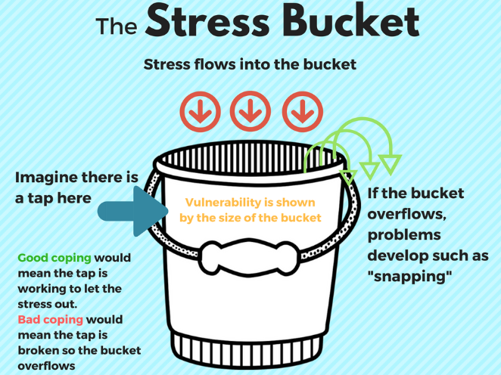

Stress Bucket Worksheet | Teaching Resources (tes.com)
The examples used in the Stress Bucket Model above may not apply to your life. Using the template below, write down some of your stressors and what activities/coping strategies you use to relieve stress. Are they helpful?



Now think about what some of your overflow symptoms may look like. You may find it helpful to write these below

The Worry Tree
Often anxiety is accompanied by large amounts of worry. Sometimes we can manage the worry and other times we can’t. The Worry Tree is a useful technique that can be used to help you establish whether there is something you can do about it, or whether this is a worry that you need to find a way of accepting or letting go.

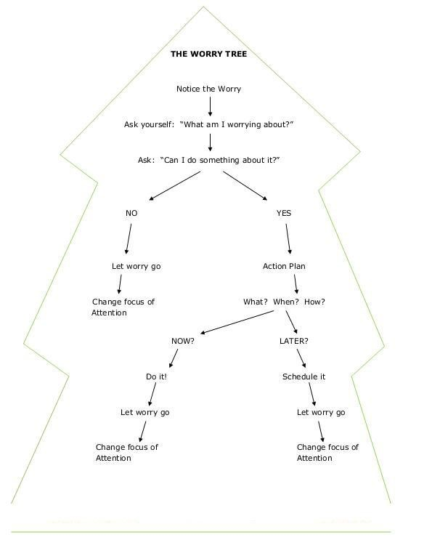

“If the problem can be solved why worry? If the problem cannot be solved, worrying will do you no good.”- Śāntideva

Well-Being

Recognising what is going well in your life is equally as important as recognising the stressors. These do not have to be big life events for example it could be making that phone call you’ve been putting off.

Write below some thoughts about what is going well in your life.

Another positive way of managing your mental health is to write down a list of what makes you happy. Use the space below to write down 3 things that make you happy.

1.

2.

3.

Think about ways you could incorporate more of the things you wrote above into your life. For example, if you like discovering new music, look for free small-scale live music events near you. If you like getting outdoors, explore where you live or see if there is a walking group you could join. Do what’s right for you, right now.

Summary

In this section we looked at:

- Who your Holder of Hope is
- The Stress Bucket Model
- The Worry Tree
- What makes you happy

Third section- Understanding Your Identity

How do you see yourself? Use the space below to draw/write.



Identify three positive words/phrases you can say about yourself

1.

2.

3.

Stigma

What are your thoughts on the stigma surrounding mental ill health?

There are two main types of stigma which occur with mental health problems: social stigma and self-stigma.

- Social stigma refers to negative stereotypes of those with a mental health problem. These stereotypes come to define the person, mark them out as different and prevent them being seen as an individual.
- Self-stigma occurs when a person internalises negative stereotypes. This can cause low self-esteem, shame and hopelessness. (www.bap.org.uk/articles/mental-health-stigma/ )

The stigma of words
Think about some of the words that are used when discussing mental health. Do any of them have negative connotations?

Reframing the way we look at mental health is an important step on the journey to recovery. For example, instead of saying “I’ve had a mental health relapse”, what if we viewed it as a ‘learning opportunity’? This way we can value all experiences as an opportunity to learn.

SMART Goals

Knowing your starting point when setting a goal is essential. Remember to start with small achievable steps that allow you to build confidence and motivation. Keep it SMART

“A journey of a thousand miles begins with a single step”

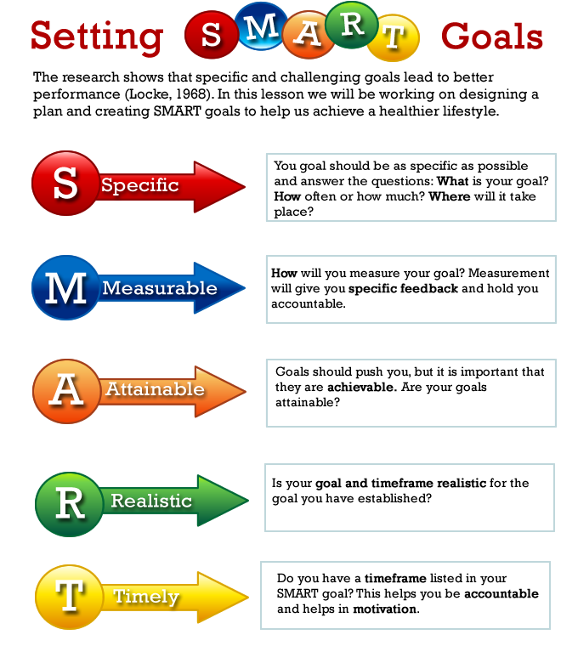

https://reigningit.wordpress.com/2015/11/01/how-to-set-smart-goals-a-goal-setting-process-to-achieve-your-dreams/

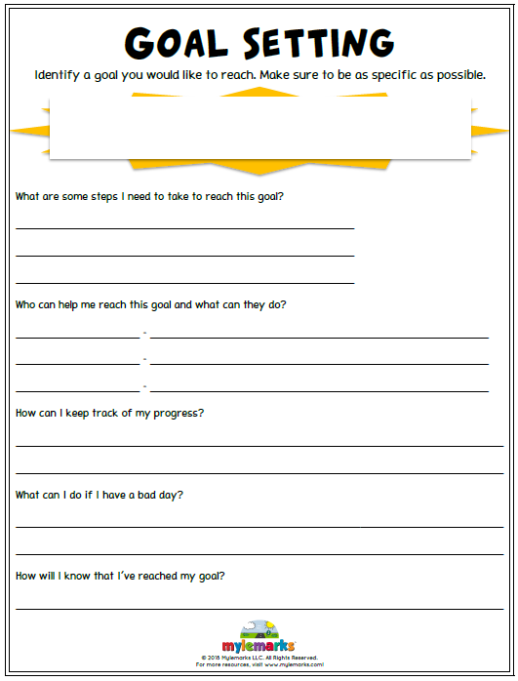
My Goal:

Summary

In this section we looked at:

- How you see yourself
- Stigma surrounding Mental Health
- Reframing stigma
- Setting Smart Goals

Fourth section - Healthy Life, Healthy Mind

Looking after your physical health and general wellbeing is linked to improving your mental health. Finding activities or hobbies that are meaningful and engaging to you is one way to take time to do this and also develop new skills.

Think about what kind of activities/hobbies you might be interested in starting.

- My interests/ideas -

- What do I need to think about to prepare to engage in this?

- What might get in the way?

- What can I do to remove any barriers?

If you’re struggling for ideas, websites such as BBC Get Inspired list club locations for different sports activities around the country: https://www.bbc.co.uk/sport/get-inspired/45353880

The website ‘Do-it’ is useful for finding volunteering opportunities of interest local to you: https://do-it.org/

Sleep

With increasingly busy, technology-focused lives, research estimates that we are getting 90 minutes less sleep a night than we did in the 1920s. Getting the right quantity and quality of sleep can have an impact on your mood and mental health.

Some researchers argue that a lack of sleep affects the part of the brain that is used for managing emotions. One result of fatigue can therefore be that people struggle to regulate their emotions which can result in negative thinking spirals. https://www.talkspace.com/blog/the-surprising-new-connection-between-sleep-and-mental-health/

The graph below indicates the sleep duration that is recommended based on different age groups. How does the amount of sleep you’re getting compare to the recommendations?
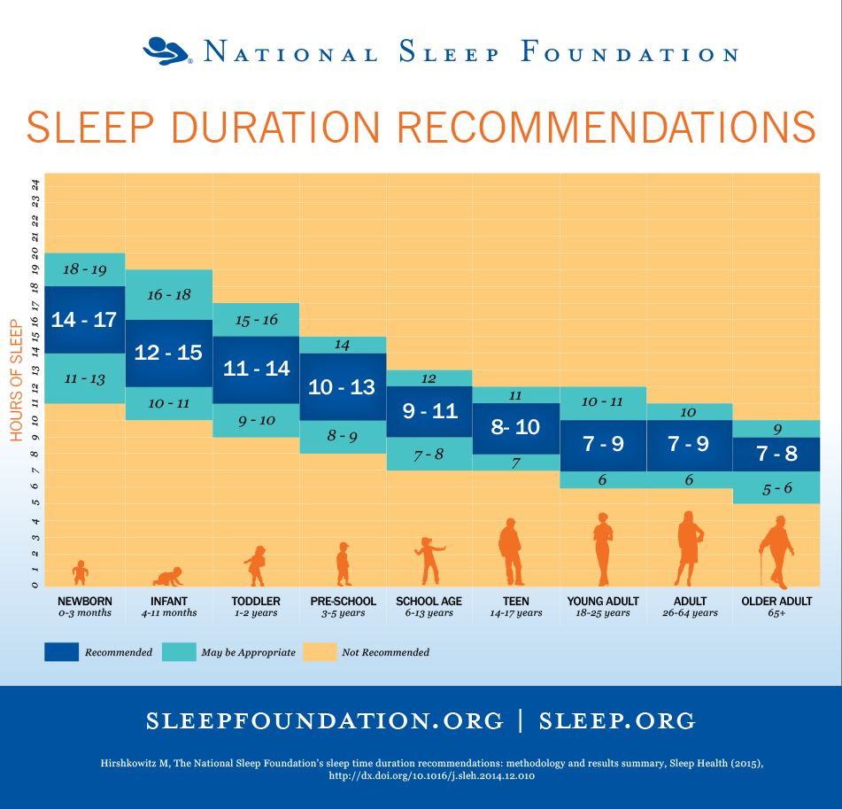

Sleep Hygiene

Sleep hygiene can be defined as practices and habits that help you have a restful night’s sleep. Some examples of good sleep hygiene can be found below.
https://www.sleepfoundation.org/articles/sleep-hygiene

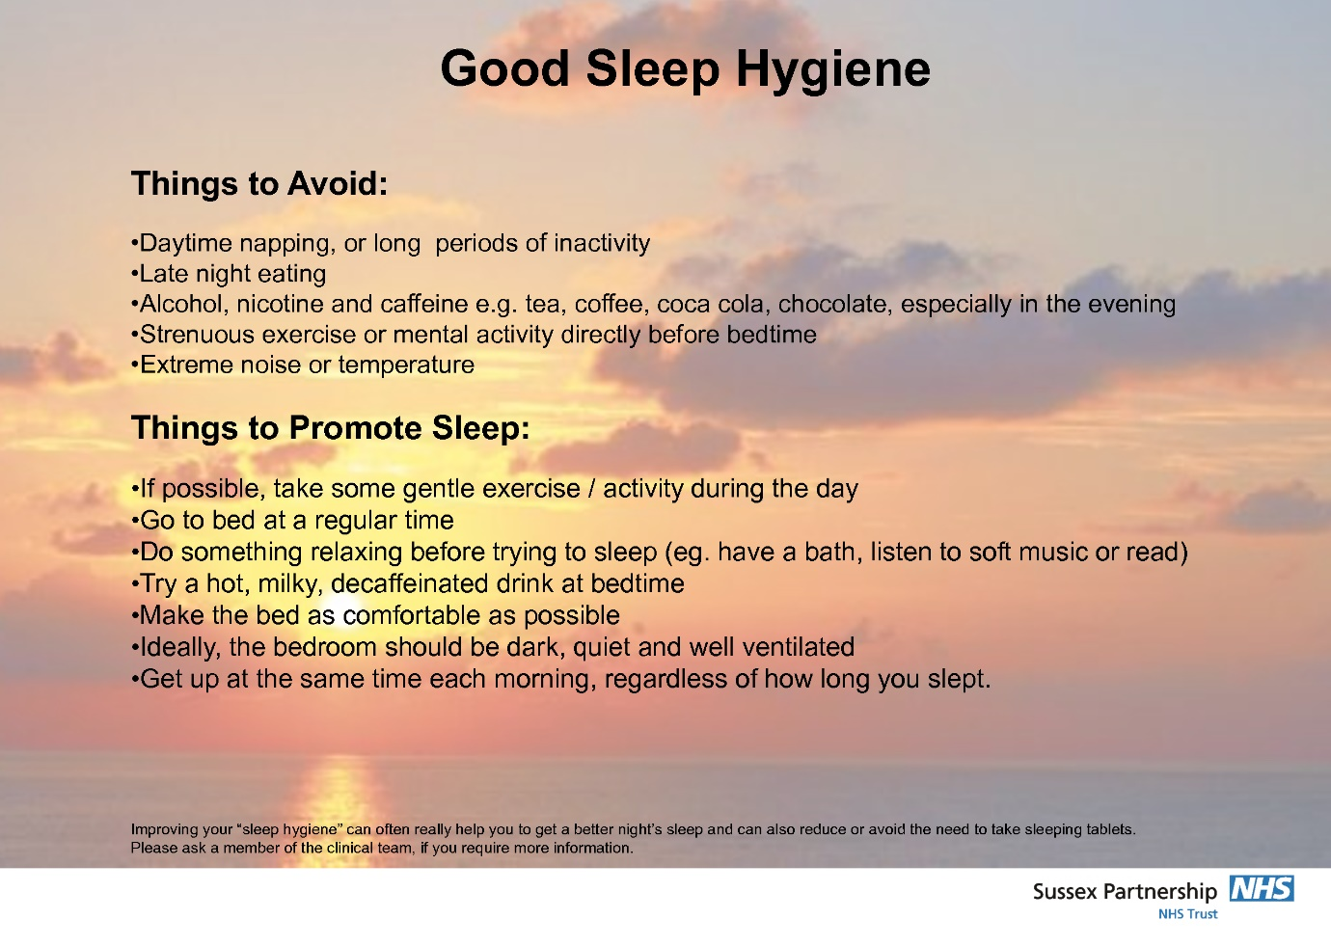

Think about or write down whether you could adopt any of the practices above to include in your sleep routine. How would you go about this?

Eating well

Eating a healthy and varied diet is another way to support your mental health recovery journey. Do you find time to cook for yourself and others or is it a cause of stress? Is this something you would like to be able to do?

If being in the kitchen is something you enjoy you could try cooking one new recipe a week, or challenging yourself to come up with a meal using only what you already have in your fridge/cupboards.

If cooking for yourself is more of a struggle, consider writing a meal plan so that if you are having a bad day it is one less thing to think about. Additionally, you could try batch-cooking meals and freezing them ahead of time.

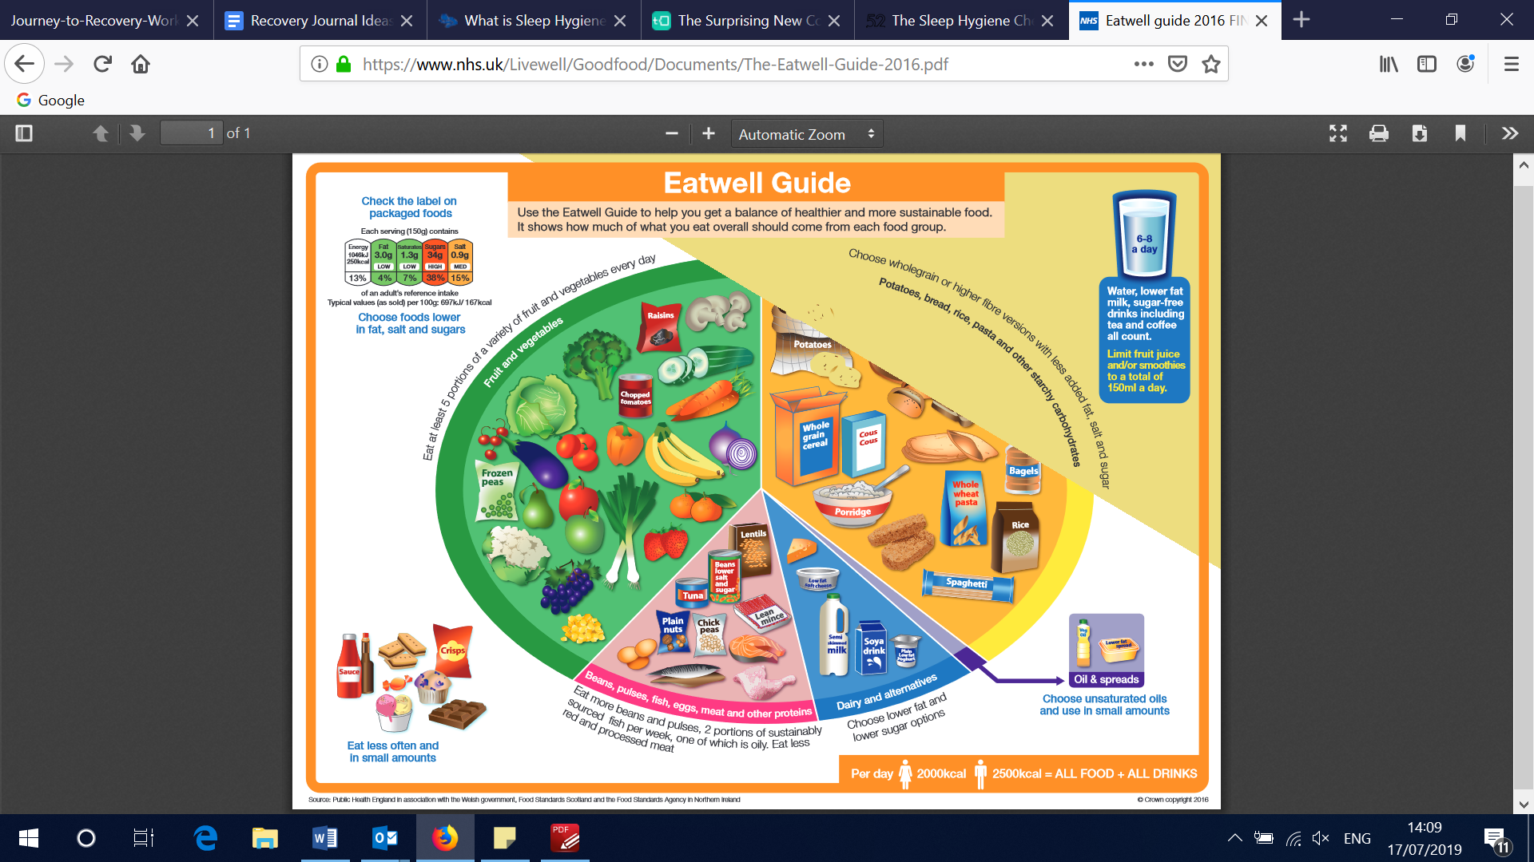
The NHS Eatwell Guide is a useful way to raise awareness around your meals.
https://www.nhs.uk/live-well/eat-well/the-eatwell-guide/

The ‘Eat Well, Spend Less’ guide provides budget meal ideas and weekly shopping plans.
https://www.kernowccg.nhs.uk/media/436449/eat_well_spend_less_booklet_-_feb2014_-_proof2.pdf

Further support: https://www.mind.org.uk/.../eating-problems/treatment-support

Exercising and Mental Health

Research suggests that physical activity changes the chemicals that the brain produces which can lead to an improvement in mood and motivation. Exercising can also help to promote a good night’s sleep. Getting active doesn’t have to mean spending hours in a gym - it’s about finding activities that you enjoy and incorporating them into your lifestyle!

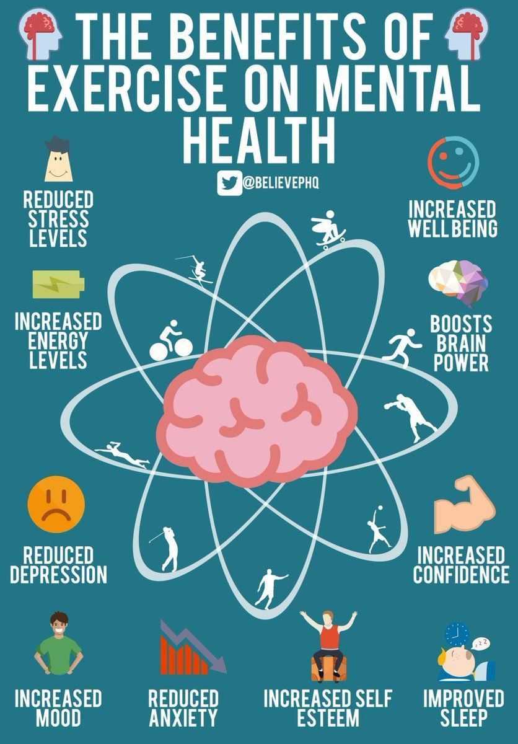

The NHS provides ideas and advice about how you can get fit for free at home or outdoors: https://www.nhs.uk/live-well/exercise/free-fitness-ideas/

If leaving the house is difficult, there are a variety of YouTube videos which provide exercise routines that can be done at home, and some fitness groups will offer single-sex classes. Websites such as ‘DoYouYoga’ provide tips for ‘deskercise’ activities which can be done whilst at work: https://www.doyouyoga.com/exercises-to-do-at-your-desk/

Summary

In this section we looked at:

- Sleep habits and hygiene
- Eating for your mind
- Exercising for improved mood

Additional activity
- Using some of the website links above- go and see what’s out there! Research fitness groups near you, create a budget meal planner or try taking up one of the sleep hygiene habits.

Fifth section: Staying Buoyant

Having the tools to deal with stress is one way of building mental and emotional resilience. This can help you take control of things and discover what works for you. Resilience is ‘not just your ability to bounce back, but also your capacity to adapt in the face of challenging circumstances, whilst maintaining a stable mental wellbeing.’ www.mind.org.uk

One way of developing resilience is to change the way you view stress or challenging situations. Instead of viewing these situations negatively seek out the opportunity to problem-solve and learn something new.
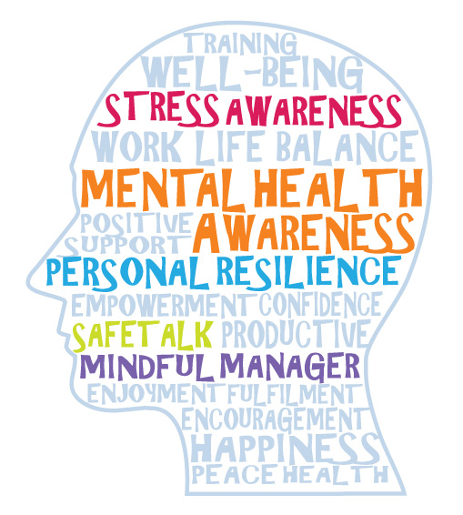
Purpose Reflection Activity
Leider’s (2015) Purpose Reflection Activity is a helpful way to define your purpose and give you something to look back on in uncertain or challenging times. Consider answering the following 8 questions. (Adapted version) https://positivepsychology.com/resilience-activities-exercises/
1 What gives you purpose?

2 What keeps you awake at night?

3 If you met an older version of yourself, what advice would they give you?

4 What helps get you up in the morning?

5 When are you most energised?

6 What can you do to make a difference in one person’s life, today?

7 If you had to summarise yourself in one sentence what would it be? (Be kind)

8 What does being successful mean to you?

Relaxation

Equally as important for building and maintaining resilience is relaxation. Take time out for yourself and do something you love. This could be an interest or hobby, seeing friends and family or getting outdoors. There are numerous breathing and relaxation techniques that work well for different people. Try some of the ones below and see if they help you.

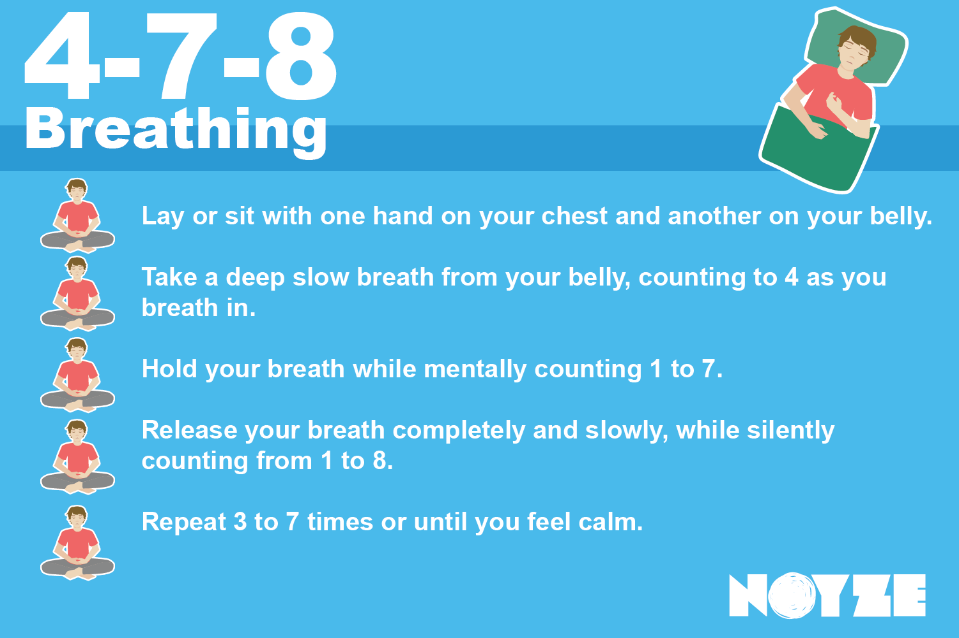

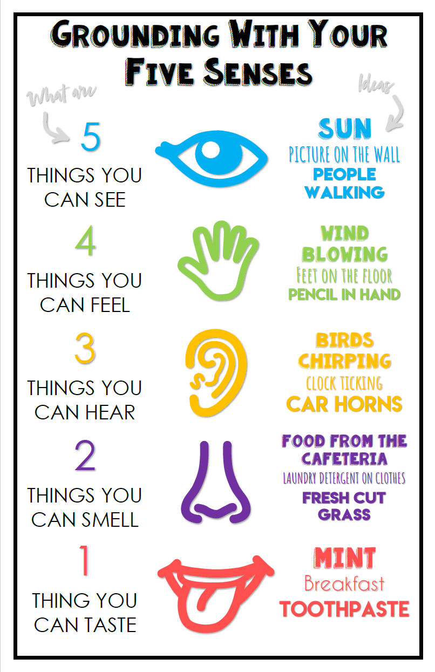

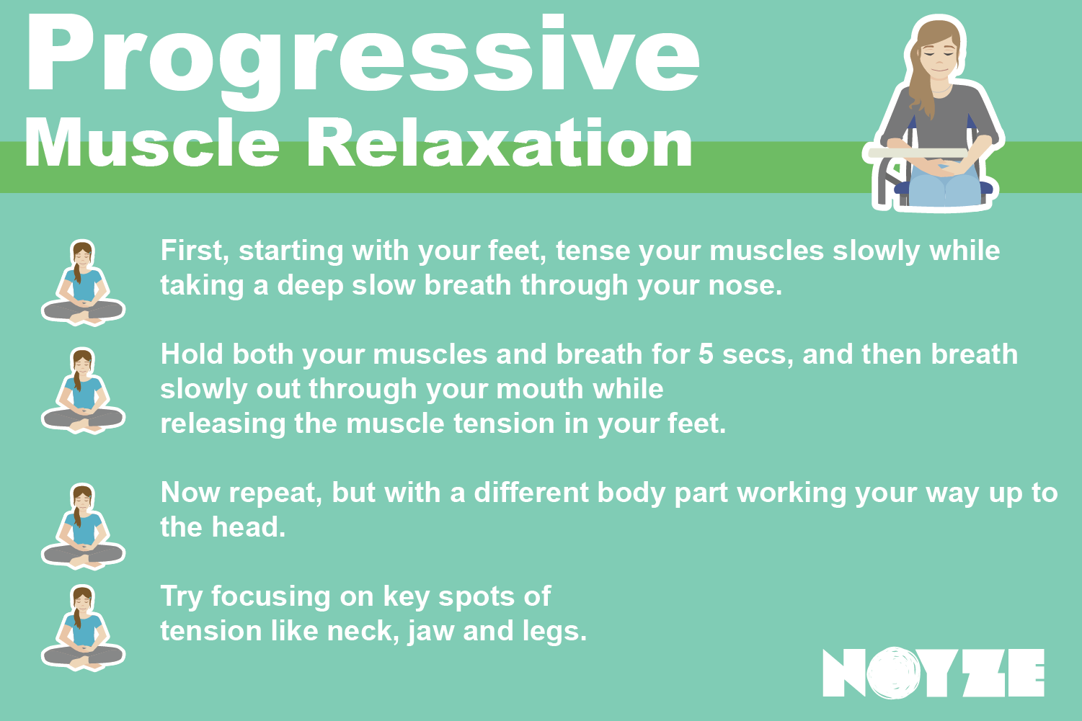

- Reward yourself for achievements
- Change up your scenery- go outside, to a friend’s house or a cafe
- Take a break from your normal routine- this can help you feel refreshed
- Resolve conflicts if you can- speak to people you have relationships with and see if you can move forward
- Forgive yourself when you make a mistake or don’t achieve what you hoped. Nobody is perfect.

https://www.mind.org.uk/information-support/types-of-mental-health-problems/stress/developing-resilience/#.XUA_S3vTU2w

Developing your support network

Building your support network is important so that you don’t have to cope alone. It can be helpful to map this out. Your support network may include friends, family, support at work or college, your GP and any other professionals you are working with.

Use the space below to identify who is in your support network. It might be helpful to include phone numbers and addresses.
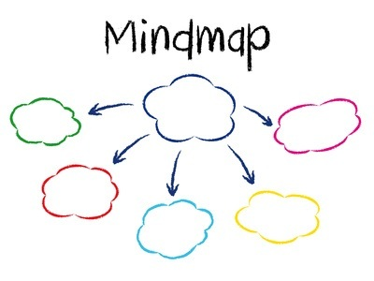
My Support Network

Summary
In this section we looked at:

- What resilience means
- Leider’s Purpose Reflection Activity
- Some techniques for coping with stress
- The importance of relaxation
- Identifying your support network

Sixth section- Onwards and Upwards!

As we are approaching the end of this Recovery Journal, take the time to reflect on how you felt at the start of the process.

Warwick-Edinburgh scale review

Look back at your answers to the Warwick-Edinburgh scale at the beginning of the Journal. How do your answers compare now?
How are you feeling about your future?

What areas do you want to work on?

Write three things you have learned from completing this Recovery Journal that you plan to carry on practicing in your journey to recovery.

1.

2.

3.

Congratulations for dedicating time and effort to your mental health recovery. Refer back to this journal and repeat any of the exercises you feel are useful. Good luck!



Mental Health Organisations

Samaritans- 116 123 - https://www.samaritans.org/ - Confidential support for people experiencing feelings of distress or despair.

Anxiety UK- 03444 775 774- www.anxietyuk.org.uk : Charity providing support if you have been diagnosed with an anxiety condition.

Bipolar UK- www.bipolaruk.org.uk : A charity helping people living with manic depression or bipolar disorder.

CALM- 0800 58 58 58- www.thecalmzone.net : CALM is the Campaign Against Living Miserably, for men aged 15 to 35.

Men’s Health Forum- www.menshealthforum.org.uk : 24/7 stress support for men by text, chat and email.

Mental Health Foundation- www.mentalhealth.org.uk : Provides information and support for anyone with mental health problems or learning disabilities.

Mind- 0300 123 3393- www.mind.org.uk : Promotes the views and needs of people with mental health problems.

No Panic- 0844 967 4848- www.nopanic.org.uk : Charity offering support for sufferers of panic attacks and obsessive compulsive disorder (OCD).

OCD UK- 0845 120 3778- www.ocduk.org : A charity run by people with OCD, for people with OCD.

PAPYRUS- 0800 068 4141- www.papyrus-uk.org : Support and advice for people living with mental illness.

Rethink Mental Illness- 0300 5000 927- www.rethink.org : Support and advice for people living with mental illness.

SANE- 0300 304 7000- www.sane.org.uk/support : Emotional support, information and guidance for people affected by mental illness, their families and carers.

YoungMinds- 0808 802 5544- www.youngminds.org.uk : Information on child and adolescent mental health. Services for parents and professionals.

Apps for Mental Wellbeing

The below apps are free and might help you with your mental wellbeing:

 | Elefriends Supportive online community from the mental health charity Mind |  | CalmHarm  Provides tasks that help you resist or manage the urge to self-harm and helps
 | Silvercloud  Programmes, tools and tactics to improve wellbeing |  | StayAlive  Pocket suicide prevention resource packed full of info to help you stay safe
 | RCPsych Mental Health App (iOS devices only)  Information on mental health disorders, videos and podcasts, and useful links |  | Happier (iOS devices only)  Helps you stay present and positive throughout the day
 | Daylio  Private diary to track your mood without having to type a single line. Pick your mood, add activities (option to add notes) |  | WellMind  NHS mental health and wellbeing app full of advice, tips and tools to help with stress, anxiety and depression
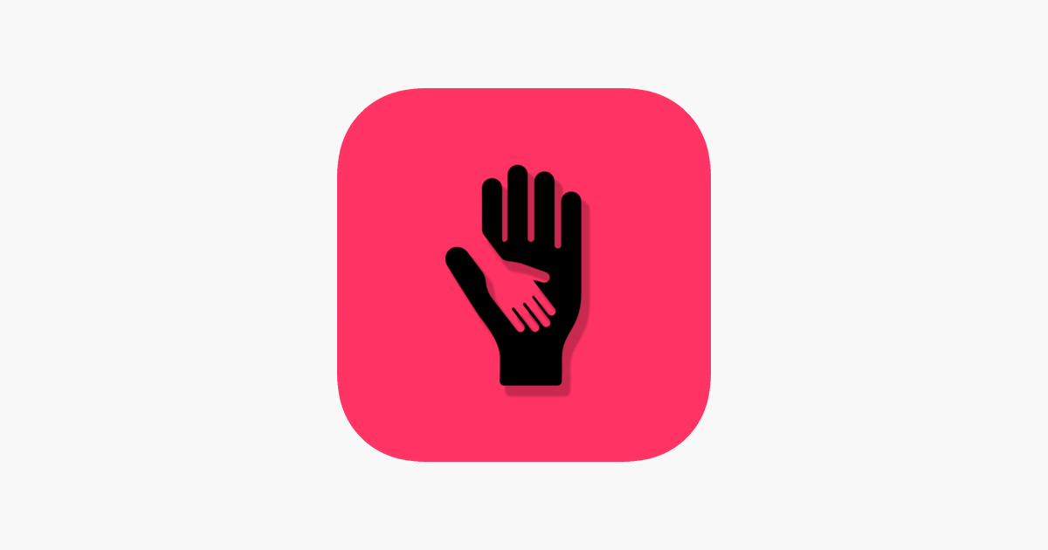 | What’s Up?  CBT (Cognitive Behavioural Therapy) and ACT (Acceptance Commitment Therapy) methods to help cope with depression, anxiety, stress and anger

